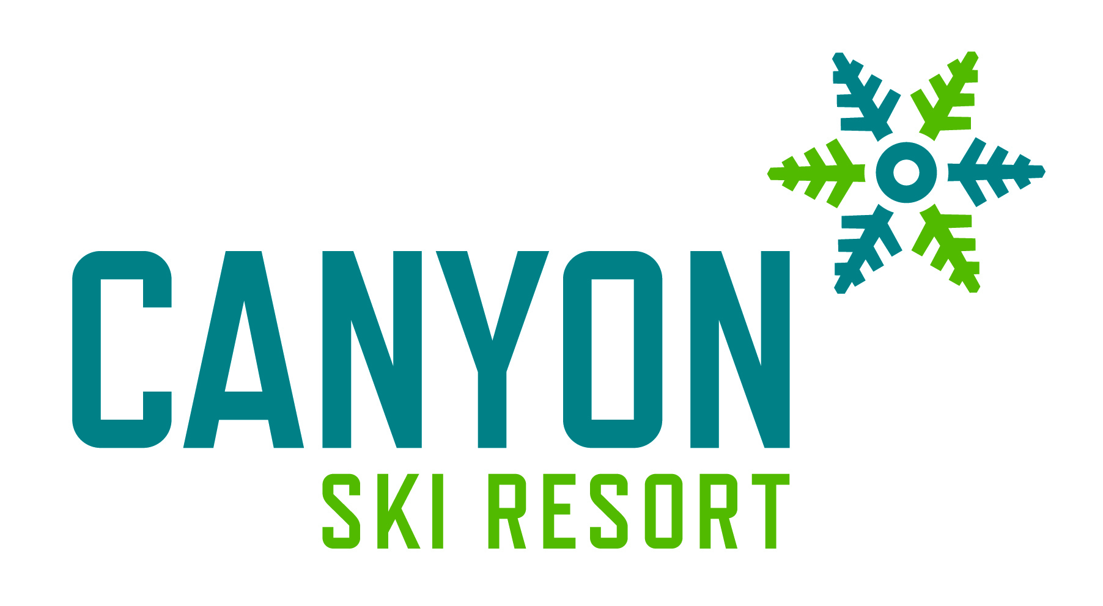
Triple Chair Backs starting at $450
Chair lift advertising is the smartest way to communicate to your customers and be close to a large number of people with great positioning. Branding the lift with your unique advertising, your business will be engaging skiers and snowboarders who are happy and relaxed during their chairlift ride. This will ensure that you will have a captive audience including; seniors, parents, teenagers, and children alike. This will not only provide entertainment during their 7 minute ride but will likely encourage discussion about your product or service. Important to note, at Canyon, the average skier is making 25-35 chairlift runs a day, and with a triple chair, you are generating three visual impressions, times 25, per ski day. This results in really taking your name to the public and puts your company brands right in front of your target audience on the slopes just minutes from Red Deer!
Triple Chair Towers starting at $650
Advertising space on a tower(s) on the Triple Chairlift is another great option for advertising! This option ensures every single person sees your advertisement regardless of their seat or position in the lift line! This cost includes providing an 18x24 inch sign with an appropriate advertisement for your business, of your design.
Tube Park and Beginner Area Name Sponsor (3 year sponsorship starting at $10,000)
By branding our Tube Park or Beginner Area with your company logo and unique advertising, your business will be engaging over 50,000 visitors a year! Snow Tubing is another great reason to enjoy winter at Canyon Ski Resort. Our Snow Tube Park is the only one of its kind in Central Alberta. With a dedicated tubing lift (so people don’t have to walk up the hill), two groomed lanes down with banked corners, and special tubes provided by us, you won’t find a better outdoor winter activity. Snow tubing has exploded in popularity and has been used for birthday parties, office parties, hockey teams, and other corporate events. This upcoming 2018/2019 season will be the seventh season and continues to grow in popularity!
Our Beginner Area is where the magic happens! This is the place where we get the next generation into the lifestyle of skiing and snowboarding!
As the title sponsor you will have:
Signage in the Tube Park including:
- Your 16”x 48” sign at the entrance of the Tube Park or The Magic Carpet
- Your company name can be printed on all Snow Tubes (for Tube Park Only)
- Your company name will be mentioned on radio ads, television ads, newspaper, web advertising, and every time there is an activity or special event held in the Park
- Your logo and Tube Park sponsor recognition in Canyon Ski Resort brochures.
- A link from our web site (www.canyonski.ca) to your web site.
- FREE Snow Tubing corporate season passes (4) for your company, its staff and families! (For Snow Tube)
- FREE corporate season passes (2) for your company, its staff and families! (For Beginner Area)

Please contact Kendra Grimes to discuss these opportunities further

